

**Customer360 Analysis Report**

By: Gia Khanh Luong

McGill University Desautels Faculty of Management

**TABLE OF CONTENTS**

Chapter I: Overview Of RFM Customer 360......................................................................4 1.1. Introduction ………………….......................................................................................4 1.2. Benefits of Customer 360 analysis.............................................................................4 1.3. Fundamental concepts in RFM Customer 360 analytics............................................5 1.4. Benefits of RFM Customer 360 analysis.....................................................................5 1.5. Customer definition by BCG Matrix.............................................................................6 Chapter II: Determine Customer Groups...........................................................................7 2.1. Define RFM.................................................................................................................7 2.1.1. Data separation........................................................................................................7 2.1.2. Build RFM SCORE scoring framework and classification in SQL. .........................8 Chapter III. Customer Analysis........................................................................................11 3.1. Overview of customer segments...............................................................................11 CODE SQL REFERENCE ..............................................................................................13

I. **Introduction**

Customer360 is a strategic tool for customer management and analysis within a business. It contains information about customers as well as comprehensive data on various aspects of the customers, ranging from demographic information and communication methods to the customer’s relationships with the business.

By consolidating all customers data into a unified platform, businesses can gain a more comprehensive and multidimensional view of their customer base. In other words, these insights allow businesses to develop specific strategies tailored to each customer segment, enhance customer experience and improve their competitiveness in the market.

**Benefits of Customer360 Analysis :**A Customer 360-degree view provides a comprehensive understanding of customers and their interactions with a business

1. **Create more strategic sales and marketing campaigns:**

* A 360-degree customer view extends the capabilities of sales and marketing teams. By leveraging existing data, these teams can develop more strategic campaigns tailored to each customer segment.

1. **Understand customers and their behaviours:**

* With a 360-degree view, businesses gain more insights from customer preferences and behaviours.
* For instance, healthcare providers can understand not only patients' medical history but also their habits and behaviours. Are regular checkups scheduled? What preventative actions can be implemented?

gain insights into customer preferences and behaviour

**3. Deliver Personalized Shopping Experiences:**

* Another benefit of this tool is the ability to provide personalized shopping experiences.
* By using aggregated data, businesses can enhance customer experiences throughout their entire shopping journey.
* For example, when a bank recognizes a customer’s new dependents preparing for college, it can provide personalized savings account recommendations based on his/her credit score.

**II. Fundamental concepts in RFM Customer 360 Analytics:**

RFM Customer 360 is a customer analysis approach built on the RFM (Recency - Frequency - Monetary) model.

This method enables businesses to assess the value of each customer based on their engagement level and tailor strategies to optimize customer care.

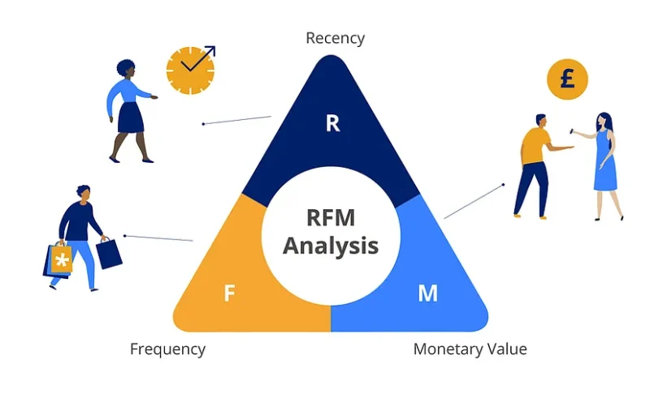

| Recency ® | Measures the time since the customer’s last purchase/transaction. The recency of the transaction can reflect the customer’s current interaction with the business |
| --- | --- |
| Frequency (F) | Measures the number of purchases/transactions within a given time. The number of transactions reflects the customer's engagement level. |
| Monetary (M) | Measures the total value of transactions that customers have made, providing insights into their significance to the business. |

**III. Benefits of RFM model:**

- Better understanding of customers: RFM analysis helps businesses have an overview of their customers, including purchase frequency, order value and the most recent time the customer made a purchase. This helps businesses better understand customer needs and come up with appropriate business strategies.

- Categorize customers and optimize marketing campaigns: After ranking each customer according to RFM criteria, we will have customer segments. This helps optimize your marketing strategy budget, improve customer interactions, and increase revenue.

- Reduce marketing costs: RFM analysis helps businesses focus on potential customer groups and devise appropriate marketing strategies. This helps businesses reduce marketing costs and optimize their resources.

**IV. Customer segmentation by BCG Matrix**

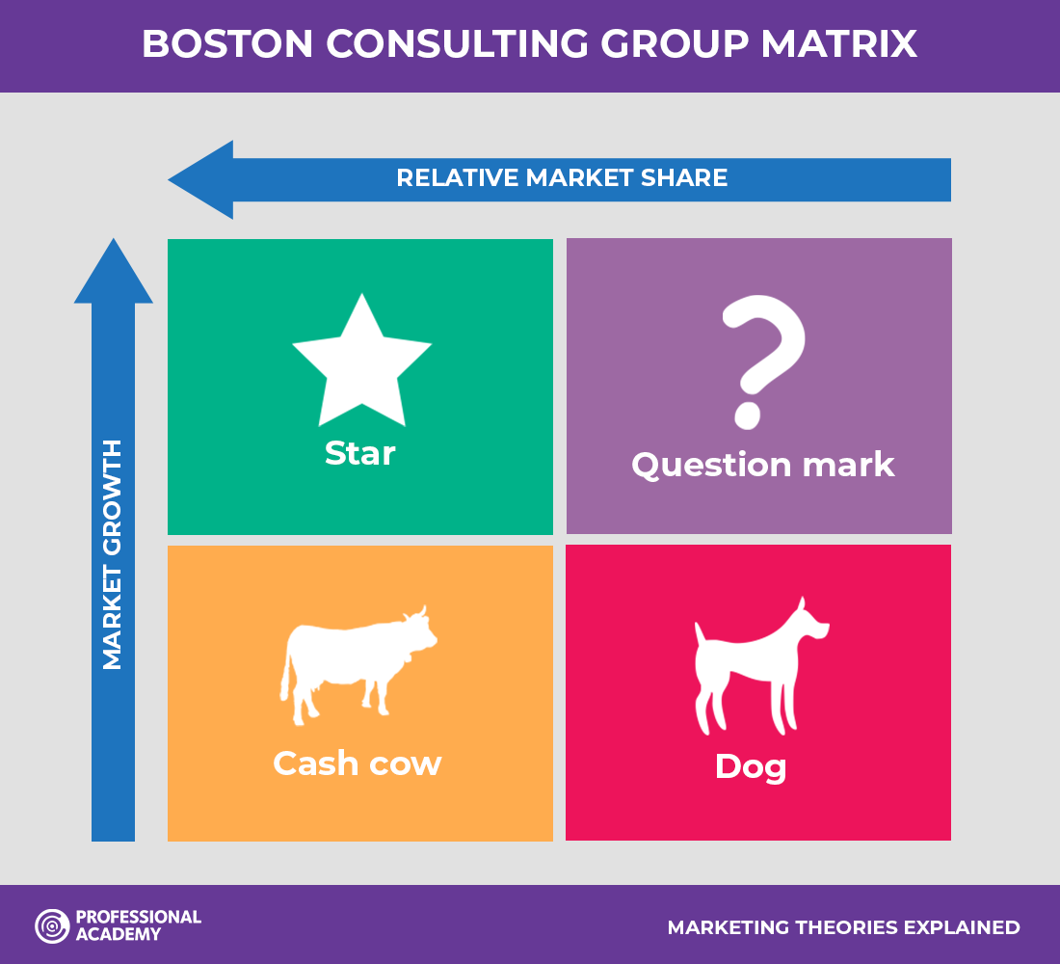

* Star - VIP group: Customers with high growth rate and relatively high market share (VIP)
* Cash Cow - LOYAL group: Customers group with low growth rate and relatively high market share
* Dog - LOST group: Customers with low growth rate and relatively low market share (LOST)
* Question Mark - NEW CUSTOMER group: Customers with high growth rate and relatively low market share

**IDENTIFY CUSTOMER SEGMENTS**

**Data description:**

There are two tables that we will need to analyze: Customer_Transaction table and Customer_Registered table

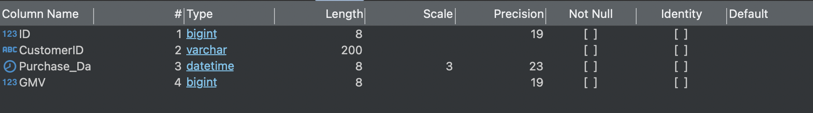

Customer_Transaction

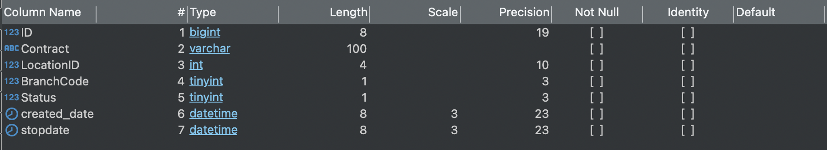

Customer_Registered

Customer_Transaction Table: records transactions of customers from June 2022 to August 2022. Each row on the table represents one completed transaction. The table has four columns [ID], [CustomerID], [Purchase_Date], [GMV]. Each transaction is identified by its transaction ID, ID of customer, purchase date and the monetary value (GMV).

Customer_Registered Table: records customers who have registered for membership cards. We will use the data from this table to calculate customers’ contract age (lifetime) and then divide it by FREQUENCY and MONETARY to ensure a fair comparison among customers over the same period. The goal is to evaluate performance across customer groups.

BUILD RFM SCORE SCORING FRAMEWORK AND CLASSIFICATION IN SQL

**Date processing using** MS SQL (Source code)

Steps:

* Process OLTP (online transaction processing) data to OLAP (online analytical processing)
* Use JOIN to join two tables and get necessary information
* Use functions such as SUM, DATEDIFF, WINDOW FUNCTION, CASE WHEN to process

**Step 1: Calculate Recency - Frequency - Monetary values**

| Convention for calculating Recency - Frequency - Monetary | |
| --- | --- |
| Recency | Time period since customers’ last purchase (starting from September 1st, 2022) |
| Frequency | Total number of purchase days/ Lifetime |
| Monetary | Total purchased amount/ Lifetime |

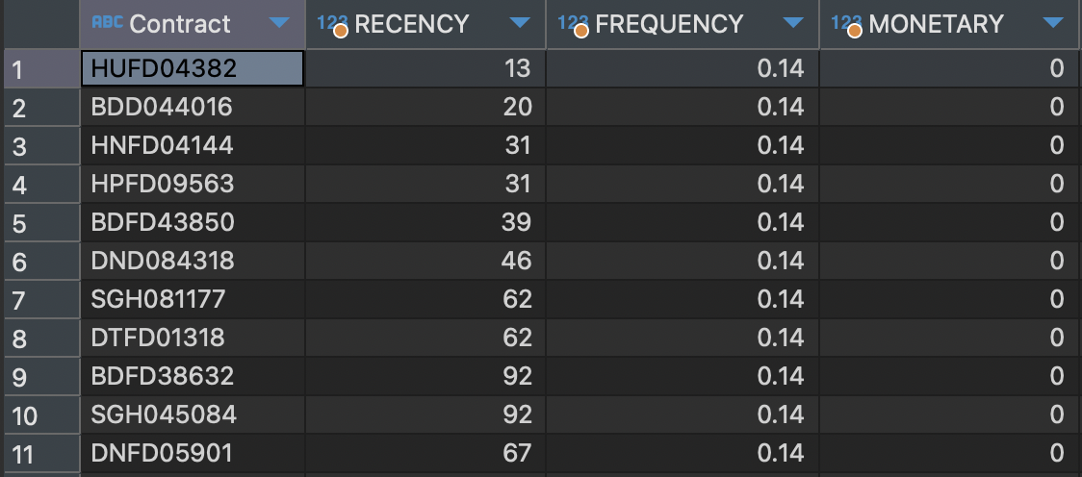

Customer_Transaction table after being processed

**Step 2: Score RFM according to IQR (Interquartile range) in SQL**

| Points | 1 | 2 | 3 | 4 |
| --- | --- | --- | --- | --- |
| Recency | >=92 | 91-62 | 61-32 | 31-1 |
| Frequency | <=0.2 | 0.2-0.25 | 0.25-0.33 | >=0.33 |
| Monetary | <=17500 | 17500 - 21250 | 21250 - 27000 | >=27000 |

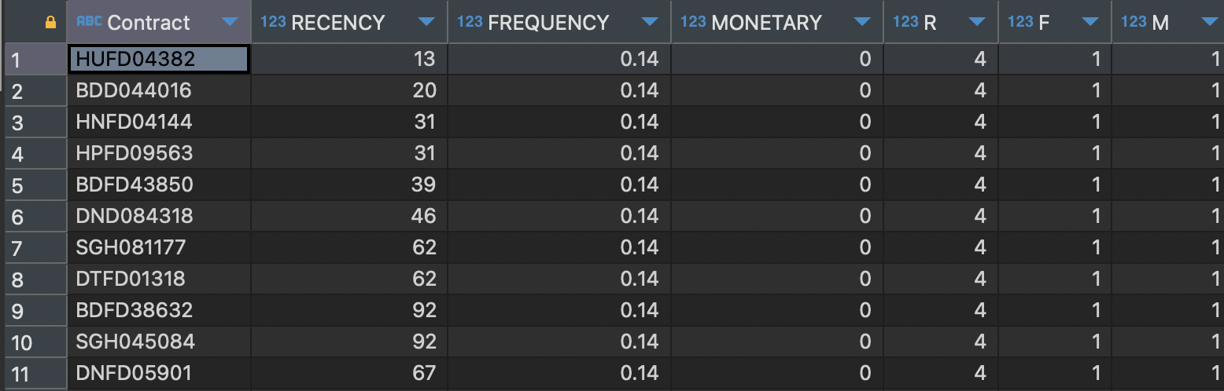

Customer_transaction table after calculating RFM according to IQR

**Step 3: Segment customers based on their characteristics**

The table below shows the characteristics of each segment and their appropriate RFM score based on their Recency, Frequency and Monetary values above.

| Customer Segments | RFM score groups | Characteristic |
| --- | --- | --- |
| VIP | 444, 443, 434, 433, 344, 343, 334 | These customers make purchases frequently but maintain an average spending level. |
| LOYAL | 441, 431, 424, 423, 414, 413, 342, 332, 323, 324, 331, 243, 244, 234, 432, 442, 333 | Customers who have recently purchased, spent a significant amount on average and demonstrate frequent purchasing behaviour. |
| LOST | 111, 112, 113, 114, 121, 122, 123, 124, 131, 132, 133, 134, 141, 142, 143, 144, 211, 212, 213, 214, 221, 222, 223, 224, 231, 232, 233, 241, 242 | These are customers who have not returned for a long time, their purchasing frequency and shopping cart value are quite low. |
| NEW CUSTOMERS | 441, 431, 424, 423, 414, 413, 342, 332, 323, 324, 331, 243, 244, 234, 432, 442, 333 | Customers who have recently purchased, have a low cart value, and do not purchase frequently. |

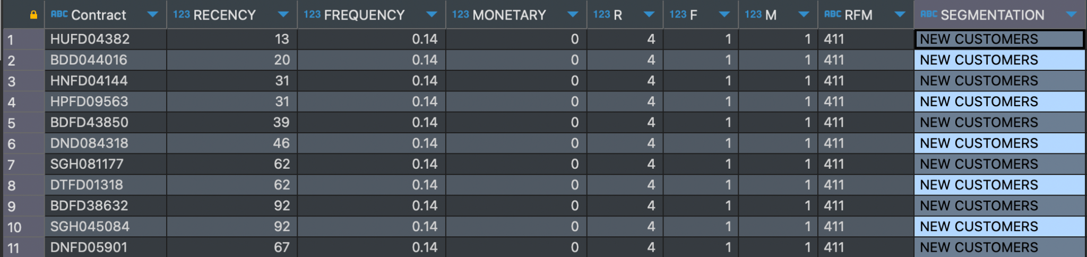

An overview of some customers with their market segment is NEW CUSTOMERS

**Customer Analysis**

Overview of customer segments

Tool: PowerBI

The store’s total revenue is 2.46 billion VND with a customer base of 111,76 thousand people

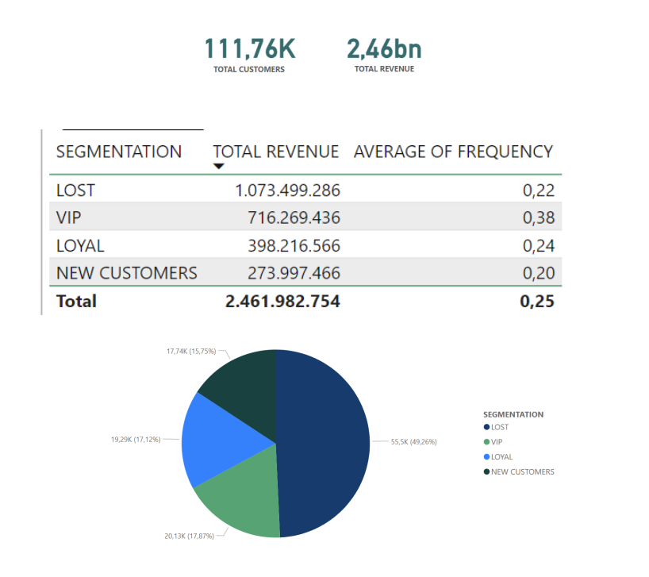

**Prioritizing VIP and Loyal Groups:** These groups have demonstrated loyalty and contributed significantly to revenue. Focus on providing services and exclusive offers to retain them and encourage continued spending.

**Potential New Customers:** While currently accounting for a small portion of revenue, this group holds the potential to become Loyal or VIP customers. Focus on delivering an outstanding initial experience and providing support to nurture their growth into a more valuable segment.

**Reconnect with the Lost Group:** Although this group has disengaged, their past contributions were substantial. Focus on finding reasons behind their departure and explore opportunities to re-engage them by addressing their concerns and rebuilding the relationship.

**CODE SQL REFERENCE**

-- Calculate Recency, Frequency and Monetary values of each contract

SELECT cr.Contract,

DATEDIFF(DAY, MAX(CAST(Purchase_date as DATE)), '2022-09-01') AS RECENCY,

ROUND(CAST(COUNT(Purchase_Date) AS FLOAT)/ CAST(DATEDIFF(YEAR, CAST(created_date as DATE),'2022-09-01' )AS FLOAT),2) AS FREQUENCY,

ROUND (CAST(SUM(GMV)AS FLOAT)/CAST(DATEDIFF(YEAR, CAST(created_date as DATE),'2022-09-01')AS FLOAT),2) AS MONETARY,

ROW_NUMBER () OVER (ORDER BY (MAX(CAST (Purchase_date as DATE))) DESC) AS RN_RECENCY,

ROW_NUMBER() OVER (ORDER BY (ROUND(CAST(COUNT( DISTINCT Purchase_Date) AS FLOAT)/ CAST(DATEDIFF(YEAR, CAST(created_date as DATE),'2022-09-01' )AS FLOAT),2)))

AS RN_FREQUENCY,

ROW_NUMBER() OVER (ORDER BY SUM(GMV)) AS RN_MONETARY

INTO #rfmcal

FROM Customer_Transaction ct

JOIN Customer_Registered cr

ON ct.CustomerID = cr.ID

WHERE CustomerID !=0

GROUP BY cr.Contract, created_date;

-- Calculate RFM Scores

SELECT Contract, RECENCY, FREQUENCY, MONETARY,

CASE

WHEN RN_RECENCY >= (SELECT MIN(RN_RECENCY) FROM #rfmcal1) AND

RN_RECENCY < (SELECT CAST(COUNT(RN_RECENCY*0.25) AS INT) FROM #rfmcal) THEN 4

WHEN RN_RECENCY >= (SELECT CAST(COUNT(RN_RECENCY*0.25) AS INT) FROM #rfmcal) AND RN_RECENCY < (SELECT CAST(COUNT(RN_RECENCY*0.5) AS INT) FROM #rfmcal) THEN 3

WHEN RN_RECENCY >= (SELECT CAST(COUNT(RN_RECENCY*0.5) AS INT) FROM #rfmcal) AND

RN_RECENCY < (SELECT CAST(COUNT(RN_RECENCY*0.75) AS INT) FROM #rfmcal) THEN 2 ELSE 1 END AS R,

CASE

WHEN RN_FREQUENCY >= (SELECT MIN(RN_FREQUENCY) FROM #rfmcal1) AND

RN_FREQUENCY < (SELECT CAST(COUNT(RN_FREQUENCY*0.25) AS INT) FROM #rfmcal) THEN 1

WHEN RN_FREQUENCY >= (SELECT CAST(COUNT(RN_FREQUENCY*0.25) AS INT) FROM #rfmcal) AND RN_FREQUENCY < (SELECT CAST(COUNT(RN_FREQUENCY*0.5) AS INT) FROM #rfmcal) THEN 2

WHEN RN_FREQUENCY >= (SELECT CAST(COUNT(RN_FREQUENCY*0.5) AS INT) FROM #rfmcal) AND RN_FREQUENCY < (SELECT CAST(COUNT(RN_FREQUENCY*0.75) AS INT) FROM #rfmcal) THEN 3 ELSE 4

END AS F,

CASE

WHEN RN_MONETARY >= (SELECT MIN(RN_MONETARY) FROM #rfmcal1) AND

RN_MONETARY < (SELECT CAST(COUNT(RN_MONETARY*0.25) AS INT) FROM #rfmcal) THEN 1

WHEN RN_MONETARY >= (SELECT CAST(COUNT(RN_MONETARY*0.25) AS INT) FROM #rfmcal) AND

RN_MONETARY < (SELECT CAST(COUNT(RN_MONETARY*0.5) AS INT) FROM #rfmcal) THEN 2 WHEN RN_MONETARY >= (SELECT CAST(COUNT(RN_MONETARY*0.5) AS INT) FROM #rfmcal) AND RN_MONETARY < (SELECT CAST(COUNT(RN_MONETARY*0.75) AS INT) FROM #rfmcal) THEN 3 ELSE 4 END AS M

INTO #RFM

FROM #rfmcal;

-- Mapping customer segments

SELECT *, CONCAT(R,F,M) as 'RFM',

CASE

WHEN CONCAT(R,F,M) IN ('444','443','434','433','344','343','334') THEN 'VIP'

WHEN CONCAT (R,F,M) IN ('441','431','424','423','414','413','342','332','323','324','331',

'243','244','234','432','442','333') THEN 'LOYAL'

WHEN CONCAT (R,F,M) IN ('111', '112', '113', '114', '121', '122',

'123', '124', '131', '132', '133', '134',

'141', '142', '143', '144', '211', '212', '213', '214', '221', '222',

'223', '224', '231', '232', '233',

'241', '242') THEN 'LOST'

WHEN CONCAT (R,F,M) IN ('422', '421', '412', '411', '311', '312',

'313', '314', '321', '322', '341') THEN 'NEW CUSTOMERS'

END AS SEGMENTATION

FROM #RFM